- Consider thefollowing initial boundary-value problem:
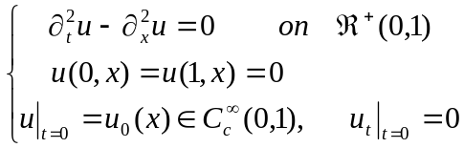 (a)
- Solving the ODE problem:
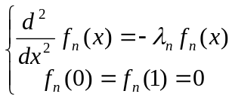 (b)
- Prove that all the solutions 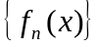 of (b)j forms on orthornal basis of 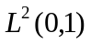. Moreover, it is complete orthornal basis.
- Try to (a) by the method of separable variables.
- Prove the uniqueness of thus obtained solution.

- Let  be an entire function with and 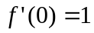. Let 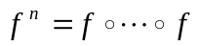 denote the -th iteration on . Suppose that these exist 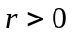 such that 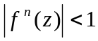 for all 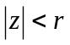and all 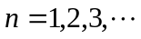. Show that 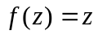 for all .

- 1) If the restriction of  to each line in the plane is continuous, is necessarily continuous?
2) Same question for differentiability(smoothness).
If yes, prove; no, give example.
3) Same question for : 